Ansible Task 03

- Write a single ansible playbook which will install apache and nginx.
Note: Playbook should not be hardcoded and pass the variables from different file.
Step 1.1 – Create Project Structure
mkdir playbook
cd playbook

Step 1.2 – Create Variable File
vi variables.yml
apache_port: 80
nginx_port: 81
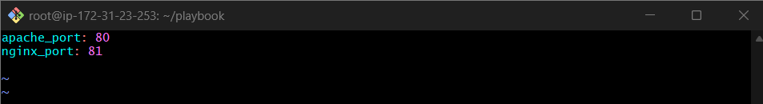
Step 1.3 – Create Playbook
vi install_web.yml
---
- name: Install and configure Apache & Nginx
hosts: all
become: yes
vars_files:
- vars.yml

tasks:
# ------------------------
# Update & Install packages
# ------------------------
- name: Update apt cache
apt:
update_cache: yes

- name: Install Apache
apt:
name: apache2
state: present

- name: Install Nginx
apt:
name: nginx
state: present

# ------------------------
# Configure Apache
# ------------------------
- name: Set Apache listen port
lineinfile:
path: /etc/apache2/ports.conf
regexp: '^Listen'
line: "Listen {{ apache_port }}"
notify: Restart Apache

- name: Configure Apache vhost
copy:
dest: /etc/apache2/sites-enabled/000-default.conf
content: |
<VirtualHost *:{{ apache_port }}>
DocumentRoot /var/www/html
<Directory /var/www/html>
AllowOverride All
Require all granted
</Directory>
</VirtualHost>
notify: Restart Apache

# ------------------------
# Configure Nginx (Ubuntu safe)
# ------------------------
- name: Disable default nginx site (port 80)
file:
path: /etc/nginx/sites-enabled/default
state: absent
notify: Restart Nginx

- name: Configure Nginx on port 81
copy:
dest: /etc/nginx/conf.d/nginx81.conf
content: |
server {
listen {{ nginx_port }};
server_name _;
root /usr/share/nginx/html;
index index.html;
}
notify: Restart Nginx

# ------------------------
# Start and enable services
# ------------------------
- name: Start and enable Apache
systemd:
name: apache2
state: started
enabled: yes

- name: Start and enable Nginx
systemd:
name: nginx
state: started
enabled: yes

handlers:
- name: Restart Apache
service:
name: apache2
state: restarted

- name: Restart Nginx
service:
name: nginx
state: restarted

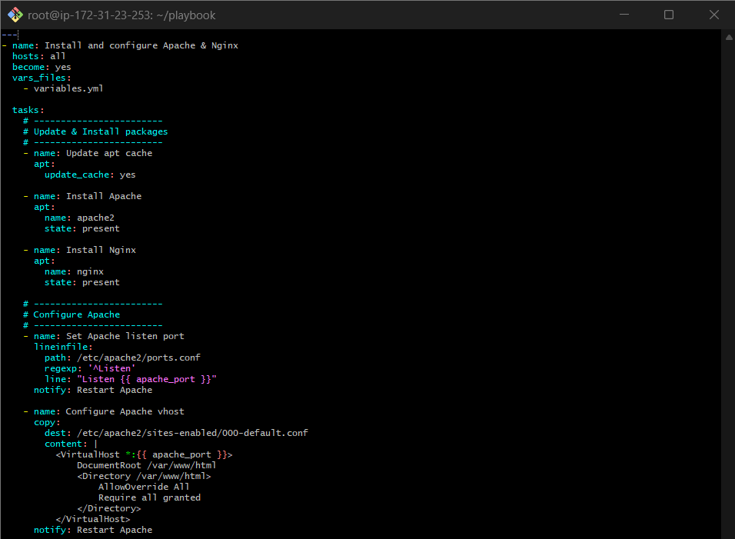
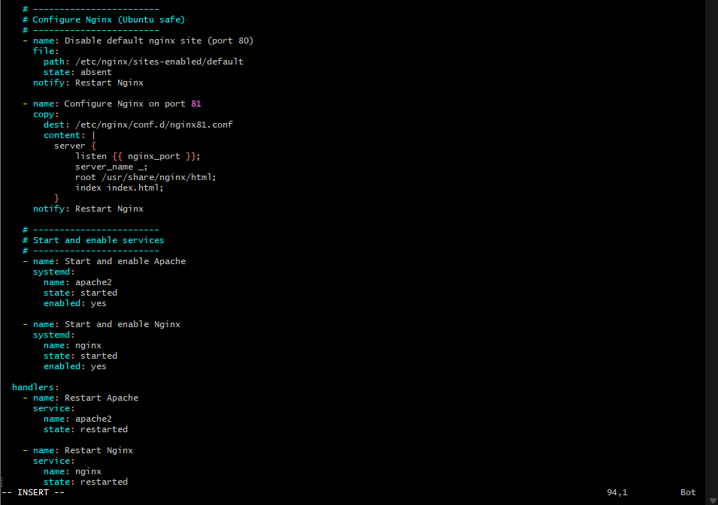

Step 1.4 – Run Playbook
ansible-playbook install_web.yml
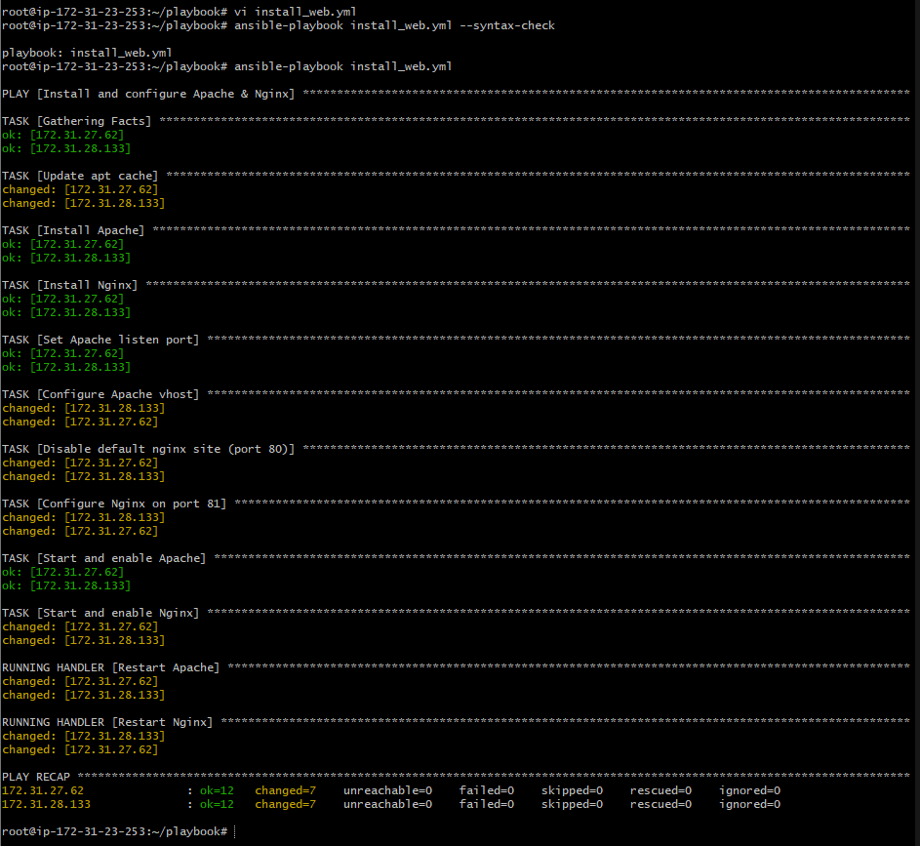

Verify: On both the worker machines Apache2 and Nginx is working or not
Worker-01
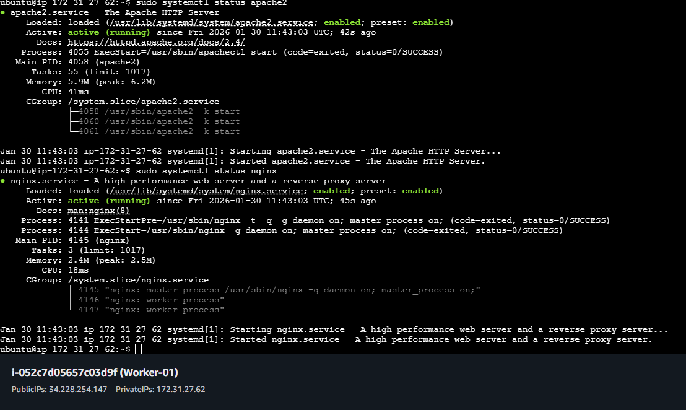
Validation on browser:
Worker-01:
Apache2: http://34.228.254.147/
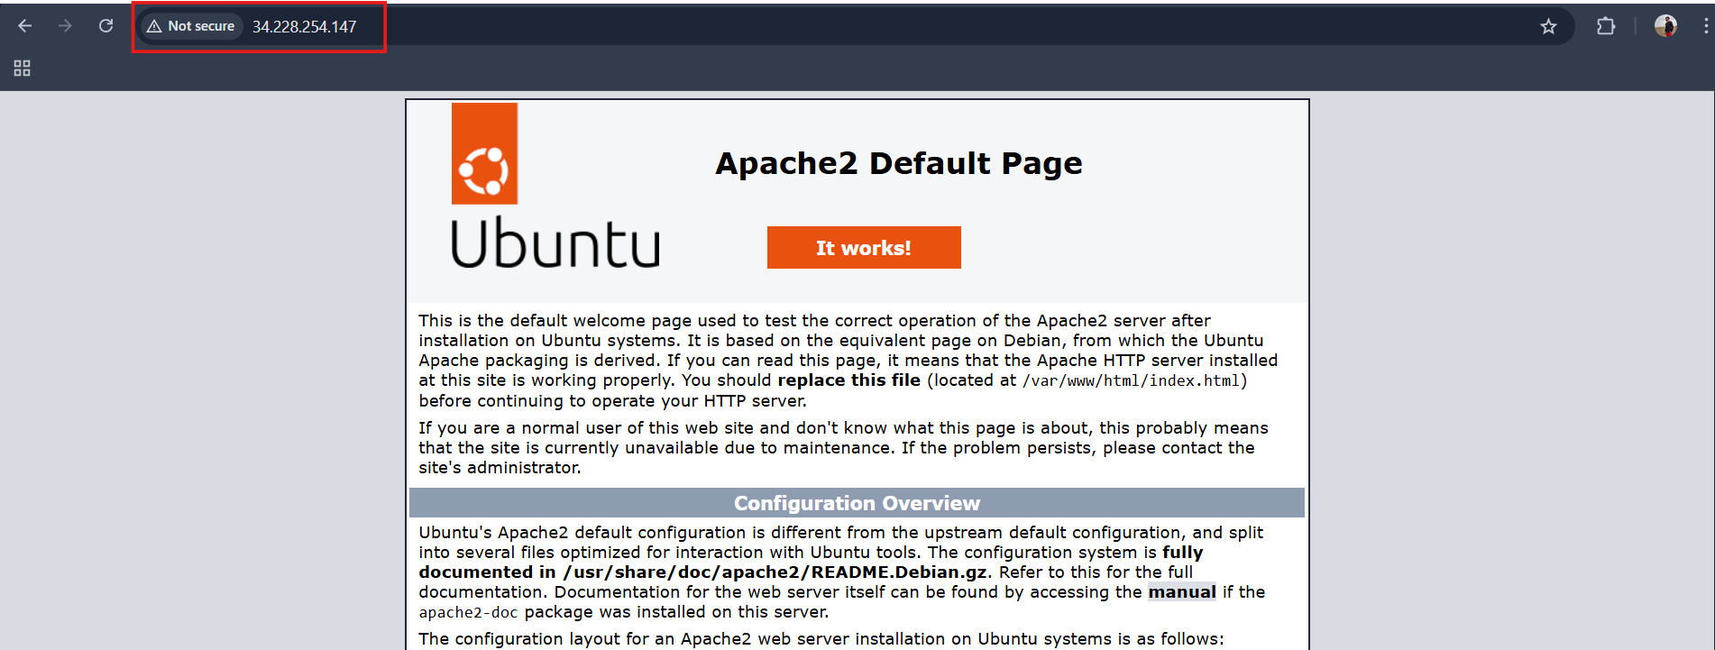

Nginx: http://34.228.254.147:81/
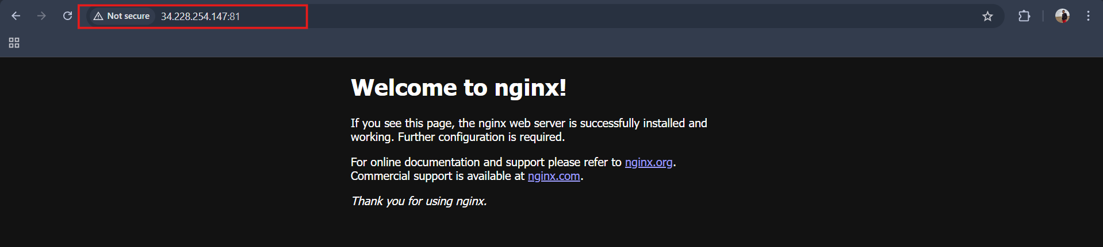
Worker-02
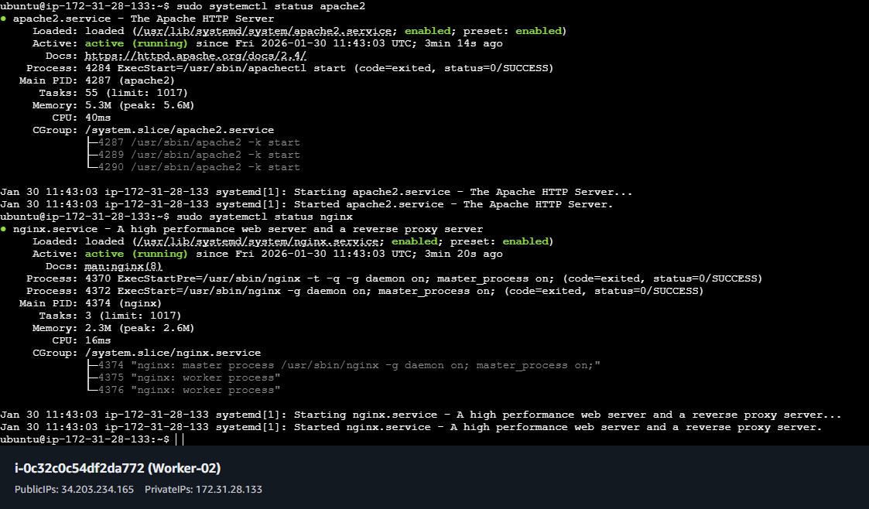
Validation on browser:
Worker-02:
Apache2: http://34.203.234.165/
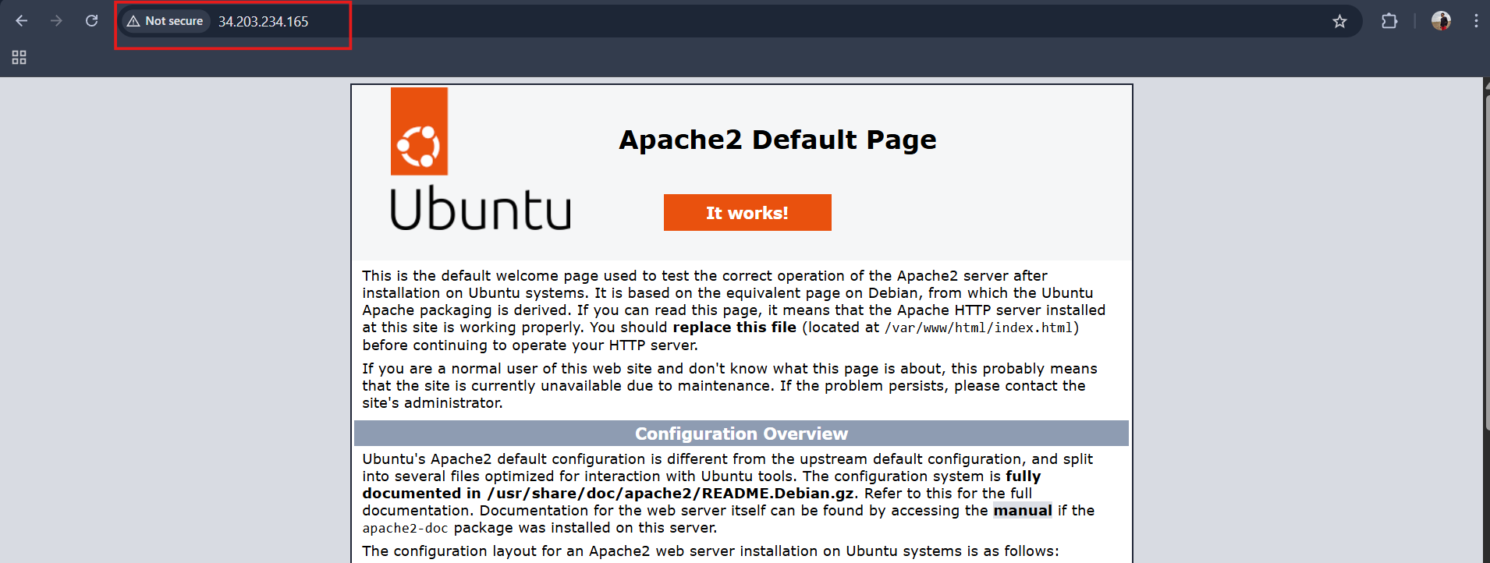

Nginx: http://34.203.234.165:81/
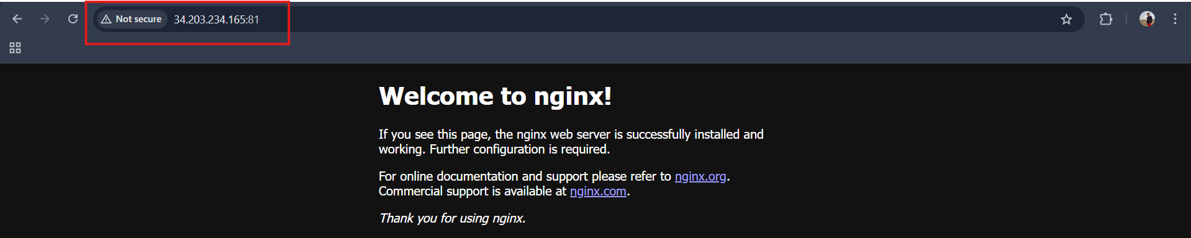

- Ansible playbook to create 10 different directories with minimal code and directory names should be passed as variables.
Step 2.1 – Create Variables File
vi directories.yml
directories_list:
- /opt/app1
- /opt/app2
- /opt/app3
- /opt/app4
- /opt/app5
- /opt/app6
- /opt/app7
- /opt/app8
- /opt/app9
- /opt/app10

Step 2.2 – Create Playbook
vi create_dirs.yml
---
- name: Create multiple directories
hosts: all
become: yes

vars_files:
- directories.yml

tasks:
- name: Create directories
file:
path: "{{ item }}"
state: directory
mode: '0755'
loop: "{{ dir_list }}"

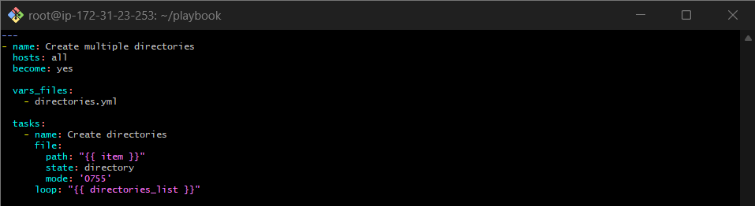
Step 2.3 – Run Playbook
ansible-playbook create_dirs.yml
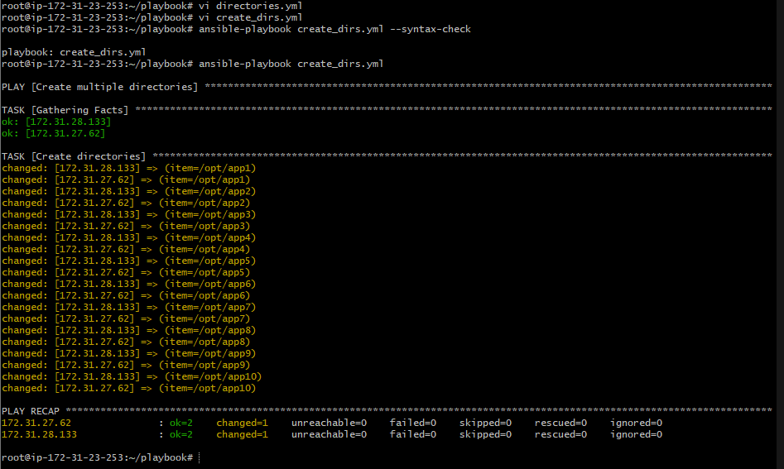

Verify: In worker machines
Worker-01
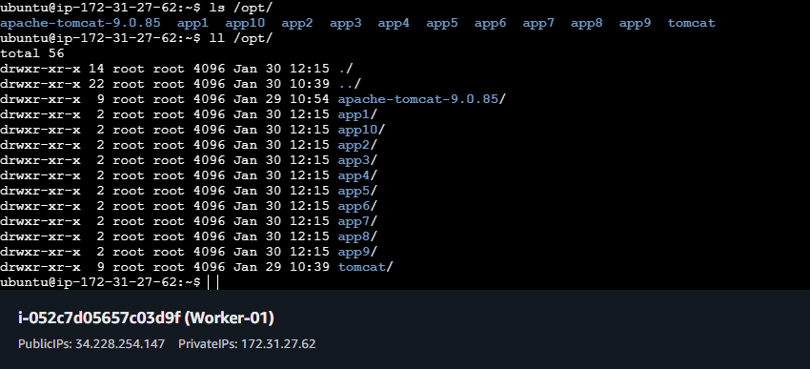

Worker-02
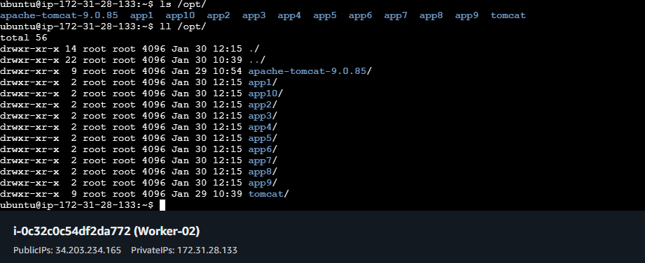

- Ansible playbook to copy ssh-keygen from master to worker nodes.
Note:
  - Provision new 3 ec2 machines, one master and two worker nodes.
Step 1 – Create Playbook
vi provision_ec2.yml

---
# Create EC2
- hosts: localhost
connection: local
gather_facts: no

vars:
r: us-east-1
ami: ami-0b6c6ebed2801a5cb
t: t3.micro
key: ansible

nodes:
- name: master
group: master
- name: worker1
group: workers
- name: worker2
group: workers

tasks:
- name: Create EC2 instances
amazon.aws.ec2_instance:
name: "{{ item.name }}"
region: "{{ r }}"
image_id: "{{ ami }}"
instance_type: "{{ t }}"
key_name: "{{ key }}"
wait: yes
tags:
Name: "{{ item.name }}"
loop: "{{ nodes }}"
register: ec2

- name: Add instances to inventory
add_host:
name: "{{ item.instances[0].network_interfaces[0].association.public_ip }}"
groups: "{{ item.item.group }}"
loop: "{{ ec2.results }}"
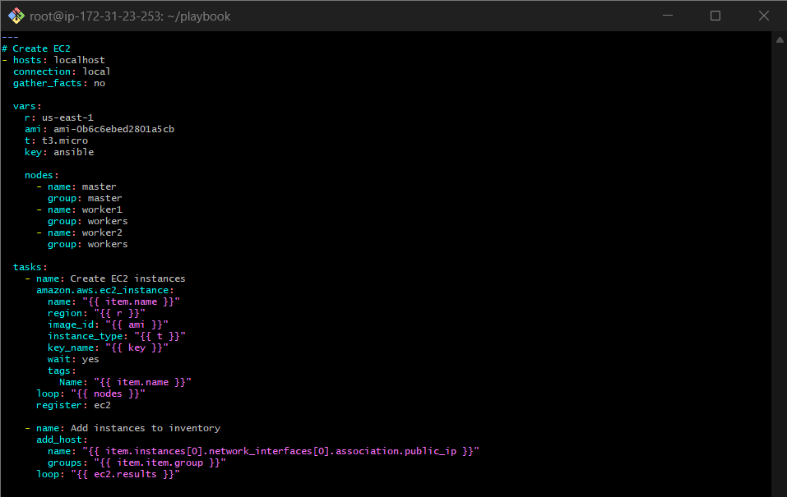
Step 3A.2 – Run Playbook
ansible-playbook provision_ec2.yml
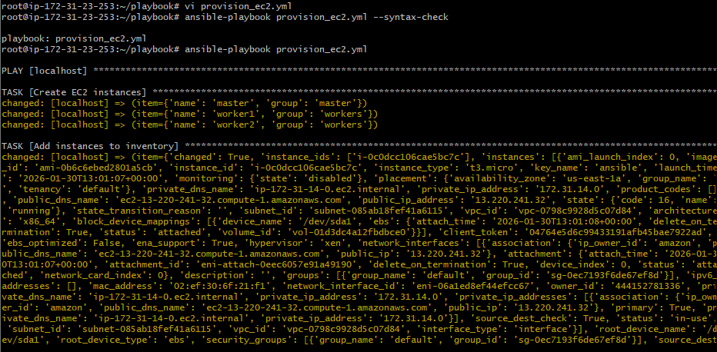

Verified on AWS Account
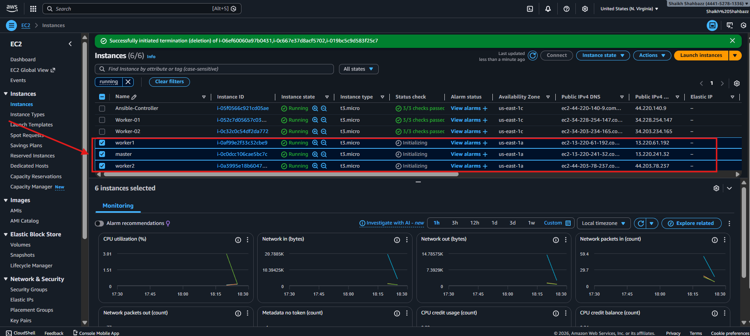

  - Create common user called shahbazz and provide sudo priviliges on 3 ec2 instances.
Step 3B.1 – Create Playbook
vi create_users.yml
---
- name: Create common user and grant sudo access
hosts: all
become: yes
gather_facts: no

tasks:
- name: Create user shahbazz
user:
name: shahbazz
shell: /bin/bash
create_home: yes
state: present

- name: Grant passwordless sudo privileges
copy:
dest: /etc/sudoers.d/shahbazz
content: "shahbazz ALL=(ALL) NOPASSWD:ALL"
owner: root
group: root
mode: '0440'

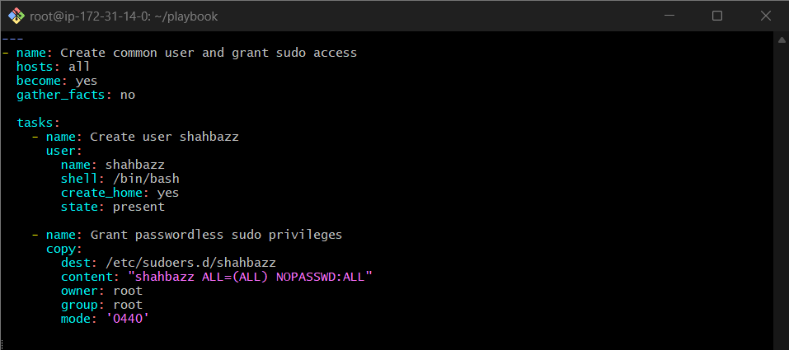
Step 3B.2 – Run Playbook
ansible-playbook create_users.yml
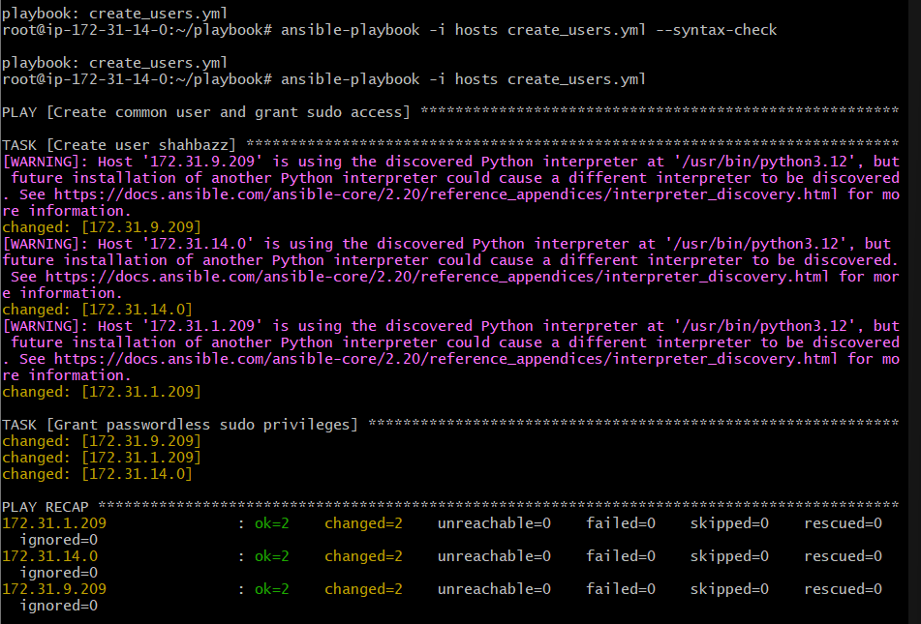

C) Create ssh-keygen in master and your playbook should copy the keygen making it password less authentication.
Step 3C – Copy SSH Key to WORKERS
Step 3C.1 – Create Playbook
vi ssh_passwordless.yml
---
- name: Generate SSH key on master
hosts: master
become: yes
tasks:
- name: Ensure .ssh directory exists for root
file:
path: /root/.ssh
state: directory
mode: '0700'

- name: Generate SSH key pair on master (if not exists)
openssh_keypair:
path: /root/.ssh/id_rsa
type: rsa
size: 4096
owner: root
group: root
mode: '0600'
register: sshkey

- name: Copy SSH public key to workers for passwordless login
hosts: workers
become: yes
vars:
target_user: shahbazz
tasks:
- name: Ensure user exists
user:
name: "{{ target_user }}"
shell: /bin/bash
state: present

- name: Ensure .ssh directory exists
file:
path: "/home/{{ target_user }}/.ssh"
state: directory
owner: "{{ target_user }}"
group: "{{ target_user }}"
mode: '0700'

- name: Copy master public key to authorized_keys
authorized_key:
user: "{{ target_user }}"
state: present
key: "{{ lookup('file', '/root/.ssh/id_rsa.pub') }}"

- name: Allow passwordless sudo for user
copy:
dest: "/etc/sudoers.d/{{ target_user }}"
content: "{{ target_user }} ALL=(ALL) NOPASSWD:ALL"
mode: '0440'

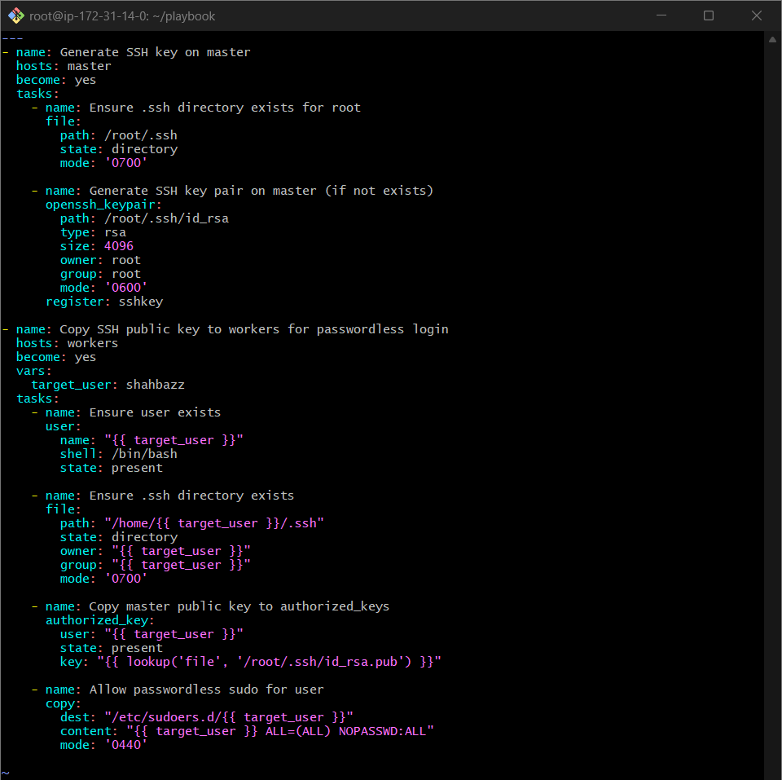

Step 3C.2 – Run Playbook
ansible-playbook -i hosts ssh_passwordless.yml
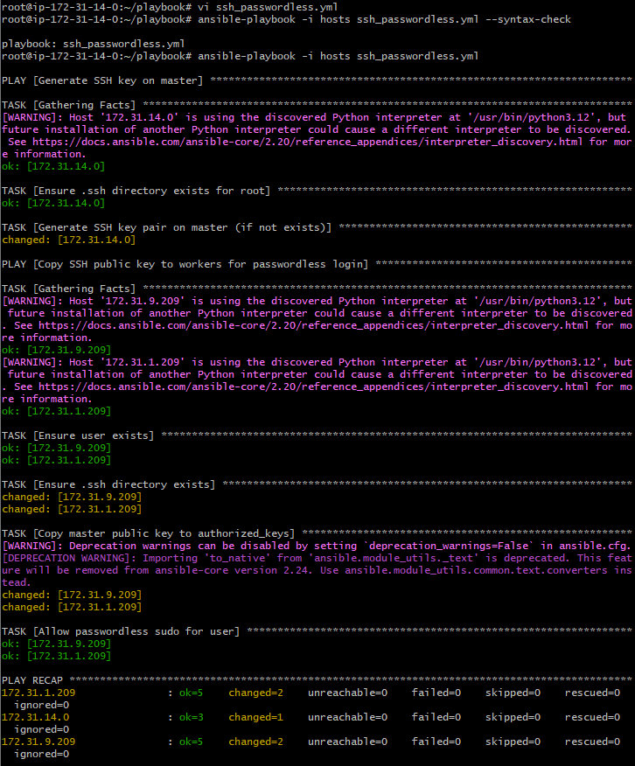

Step 3C.3 – Verify
Now are able to connect to our worker mashines
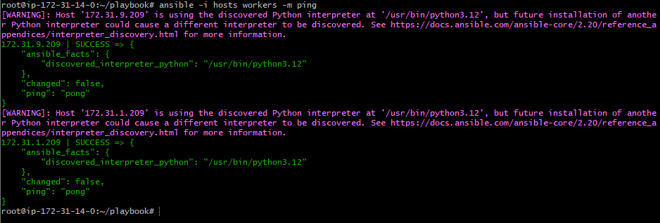
Worker1
sudo su - shahbazz
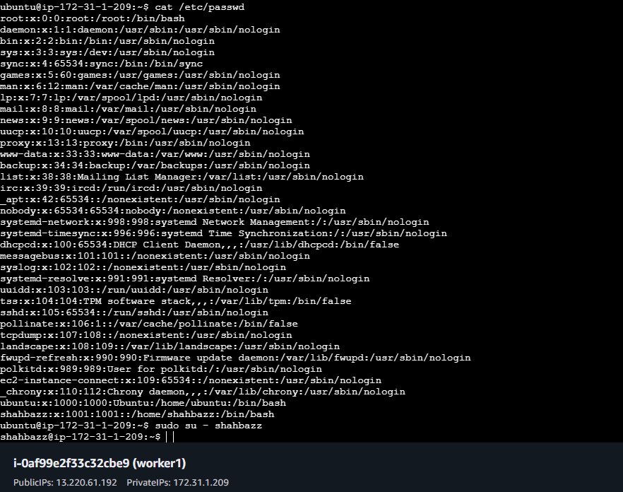

Worker2
sudo su - shahbazz
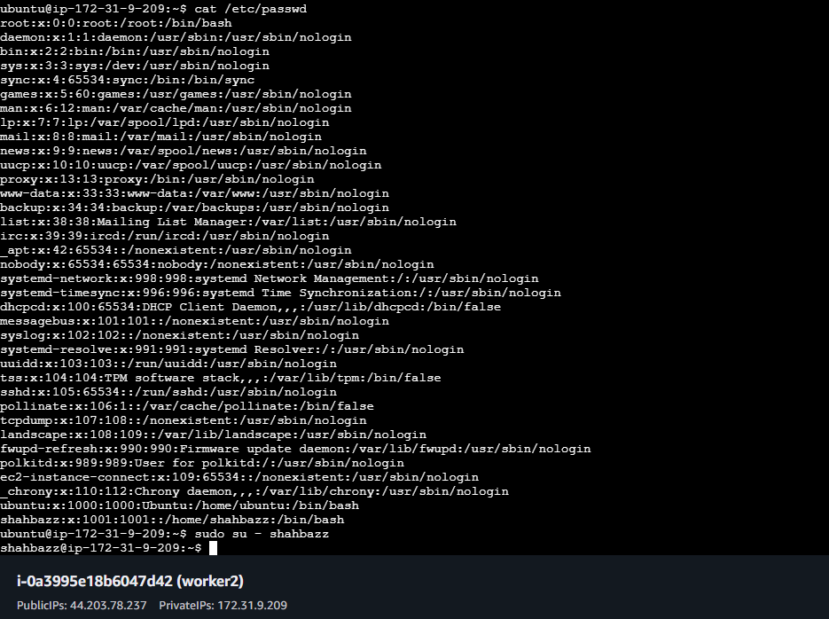

- Ansible playbook to inject ansible vault variables.
Step 4.1 – Create Vault File
ansible-vault create vars/vault.yml ----------- password: ansible123

vi vault.yml
db_user: admin
db_password: MyStrongPassword
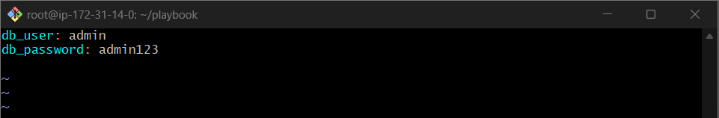
Step 4.2 – Create Playbook
vi vault_playbook.yml
- hosts: all
become: yes
vars_files:
- ../vars/vault.yml

tasks:
- name: Use vault variables
debug:
msg: "DB User={{ db_user }}"

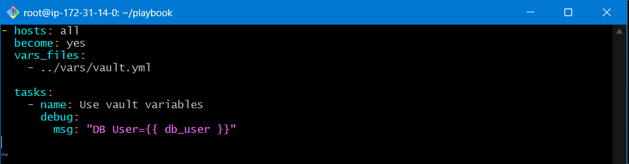

Step 4.3 – Run Vault Playbook
ansible-playbook -i hosts vault_playbook.yml --ask-vault-pass
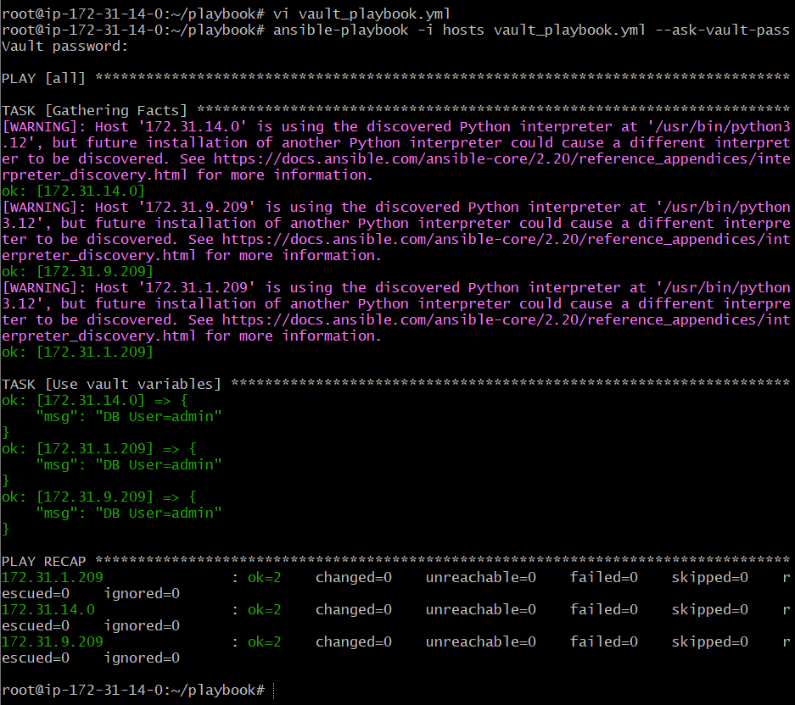
Step 4: Verify file Is encrypted
cat vars/vault.yml
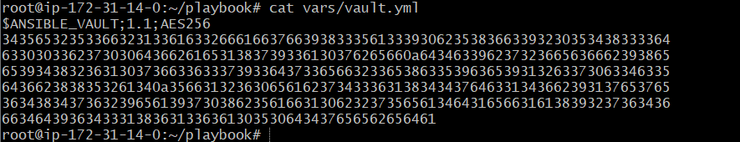

Step 5: ansible-vault view vault.yml
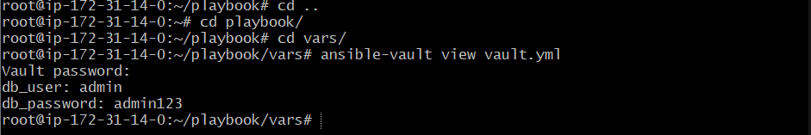

Step 6: ansible-vault decrypt vault.yml
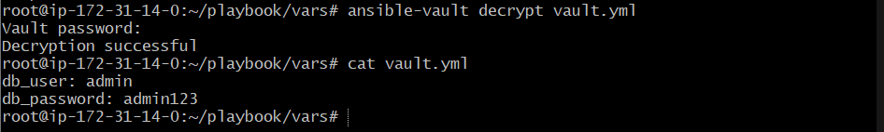

Other Vault usefull commands:

Purpose | Command
Create a new vault file | ansible-vault create <file.yml>
Edit an existing vault file | ansible-vault edit <file.yml>
View a vault file (read-only) | ansible-vault view <file.yml>
Encrypt an existing file | ansible-vault encrypt <file.yml>
Decrypt a vault file | ansible-vault decrypt <file.yml>
Change vault password | ansible-vault rekey <file.yml>
Run playbook with vault password | ansible-playbook <playbook.yml> --ask-vault-pass
Run ad-hoc command using vault variable | ansible all -i hosts -m debug -a "msg={{ var_name }}" --ask-vault-pass

